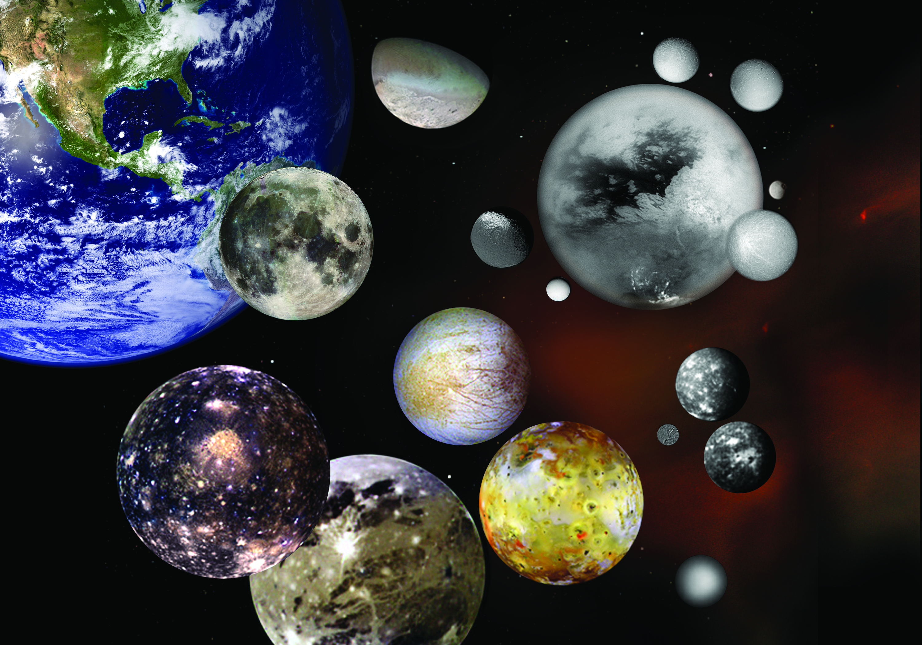
Developing the Planetarium Show “Moons of our Solar System”

Matura paper by Lukas Hänggi
Kantonsschule Schaffhausen
4mc
December 2013

Supervised by Rainer Steiger and Andrea Jedlicka
Table of Contents
1 Introduction 2
2 The Setup 3
2.1 The Program 3
2.2 The planetarium 4
2.3 The programmer’s Laptop 4
3 Construction of a show 5
3.1 Finding a subject 5
3.2 Developing Concepts 6
3.2.1 The visual concept 7
3.2.1 The aural concept 7
3.3 Programming 8
3.3.1 Framework 8
3.3.2 Specials 9
3.3.3 Details 9
3.4 Assembly 10
4. Afterword 11
Printed Sources: 14
Internet Sources: 14
Conversations: 14
8. Attachments 15
8.1 Presenter’s script 15
8.2 Visual concept 20

1 Introduction

In this paper I will describe the processes needed to produce a show for the planetarium of Schaffhausen’s observatory. To do so, I will program my very own show, which, hopefully, will eventually be shown at the observatory itself on a regular basis. Because of the enormous effort involved in programming a 50-minute show, mine will only last about 30 minutes.
I came upon the subject of this paper through my family. My father was the director of the old observatory. And ever since the new observatory was built in 2012, my whole family has been working there. As I was searching for a subject for my show, my father offered me to come along and help him program certain scenes in the soon-to-be published show “Voyager”. Whilst doing so, I discovered an interest in programming and I continued to help my father with programming certain scenes. It was also clear to me from the beginning that I wanted to do something extraordinary, something that only I could do. I wanted to do something that was not similar to any other paper done before it. So I decided to produce this show, as I had the perfect conditions and the required resources to do it: I had been assisting other presenters in the observatory before, my father was one of the programmers, and I could access the planetarium at will.
However, I still needed a subject for the show itself. I spoke to some members of the observatory and sought for a subject that interested me. After evaluating various subjects, I finally decided on “Moons in our Solar System” as the subject is not overly extensive, nor too small. It’s limited to a well-known sector of space, and it includes many different and very interesting objects such as Jupiter’s Galilean moons, or the tiny moon of Saturn, Mimas.

2 The Setup

2.1 The Program

The Program used in the planetarium of the observatory in Schaffhausen is Called Digital Sky 2. It is software developed by Sky-Skan, for full-dome projection. Its primary function is to show space on the dome-screen of a planetarium working with Definiti-technology. Another one of its functions is to display multimedia as well as other animations like structural molecules.
Constructing a show in this program is structured quite simply. The interface consists of a set of programmable buttons. These buttons are arranged in a 12* 8 grid. At the same time another window (while programming on the laptop) or the projector (in the planetarium itself) is showing the visual output of the program. A show consists of a sequence of several buttons, pressed one after the other, mostly in a fixed order. There are some exceptions to this as there are, sometimes, optional buttons, which cause an extra orbit around a body or something similar. Each button is individually programmed. The extent of the programmed actions per button is infinite, however it’s usually kept to around 30- 50 lines of code for the reason of simplicity.
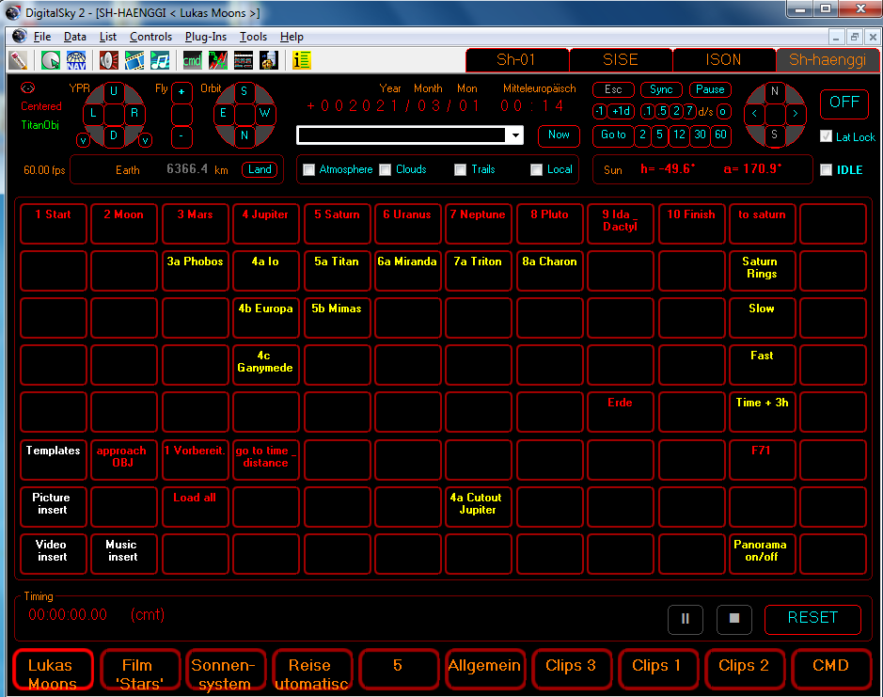

2.2 The Planetarium

There are several different components that are needed to run the planetarium. The heart of the planetarium is the Definiti Projector, which is located in the center of the square room. Aligned exactly above the projector is the full-dome screen. It is made up of a lightweight metal. It is perforated and painted white. The white paint guarantees a high quality picture, as the dome serves as a screen. The perforations keep the weight of the dome to a minimum, which makes it easier to build a structure to suspend it from. There is a full surround-sound system installed in the room. Under the dome, there are about 25 chairs, all orientated towards the sweet-spot. The sweet-spot is the place on the dome, where an object in space is centered. It is so to speak the center of the screen. The projector and the sound system are connected to a computer. There are two computers in total, one for running the program as well as the sound and one for rendering the image that is projected onto the dome. The computers are located in the back right-hand corner of the room, due to the little space available in the room. There is also a table with two screens, the sound-control unit and two red lamps, for dim lighting. The screens display the presenter’s script as well as the program with all its controls.

2.3 The Programmer’s Laptop

For programming outside the planetarium, there is a laptop. This laptop runs the same software as the planetarium. It displays the image, which is usually on the dome in a separate window. As the laptop is less capable than the rendering-PC in the planetarium, there are certain limits as to what can be displayed without lag occurring. As an example there is a scene in which the observer flies into the rings of Saturn. As everything in this program is rendered in real-time, the laptop cannot keep up with rendering the image. The rendering process itself takes up several gigabyte of RAM, which the laptop simply does not have.

3 Production of a show

There are several steps or parts to the production of a show. First of all, a suitable subject must be found. This is the most fundamental part, as it sets the parameters for the whole project. The second step is to develop concepts for both the visual and aural components of the show. The visual concept is what will actually be shown on the dome of the planetarium. It describes the sequence of actions on screen, as well as which button in the operators console will have what effect. The aural concept describes what the presenter will say during the show. It consists of a script, which the presenter has on screen as a guide during the presentation. The next step is the actual programming. This implies programming each button so that it will function as it is supposed to, as well as making the single buttons work together fluently. Afterwards the show and script are put together and each is in turn adjusted to the other. After this, the show is almost complete. Some fine-tuning of the programming is usual to make the show visually more appealing. Each presenter usually introduces the content of the script in an individual style, and adds on or leaves out certain bits of information.

3.1 Finding a Subject

A good subject is the most vital part of any show. Therefore, finding the right subject can be tricky. There are several criteria for what makes a good subject. First of all it has to be based on an interesting theme. A subject that is interesting to all ages is highly preferable, as families often visit the observatory with smaller children, as well as adults who are more familiar with space. The second criterion is the general complexity of the subject. If it is too complex, it will be very difficult to explain and fully understand, even to an adult, within the 40 to 50 minutes that a presentation lasts. Also, not all visitors are familiar with space and its nature. Therefore, a subject must be comprehensible and based only on minimal knowledge on astronomy. Another limiting factor is the extent of the subject. 50 minutes is a very short timeframe. And in the endlessness of space it is very easy to find a subject, which simply cannot be covered in its entirety within these 50 minutes.
As for my show, the subject is “Moons in our Solar System”. I chose this subject for several reasons: First and foremost, moons are a very appealing theme. They are very different from each other. There are many different and fascinating moons in our solar system alone. These range from our very own moon, over the volcanic moon Io, which orbits around Jupiter, to the far reaches of the solar system where Charon orbits Pluto, which is just slightly larger than Charon itself. Another advantage of this theme is that it is not overly complicated. It is not extremely hard to explain the compositions, formations and orbital behavior of moons, as they are mostly very stable objects. Surely there are some more complicated phenomena associated to moons, but these are not enormously important, as they have little effect on the solar system as a whole. This brings me to the next advantage of this subject. It is easy to limit. Firstly, it was limited to our solar system only, as moons orbiting extrasolar planets are too numerous as well as not yet explored well enough. Secondly, it is limited by the complications associated with explaining certain behaviors. This limits the subject nicely.

3.2 Developing Concepts

There are two concepts to be made, the visual concept, and the aural concept. A different person makes each of the two concepts. The programmer writes the visual concept, as he is very familiar with the abilities and limitations of the program, and the aural concept is created by the texter. He or she is usually someone who is very talented in the linguistic field. The two concepts are coordinated and go through the same scenes of the show. They ultimately need to fit together perfectly, to allow a smooth presentation of the show itself. Some problems I encountered were due to then still lacking knowledge of the program. I assumed it was possible to do things, that I later found out were not feasible. On the other hand however, I picked several ideas back up, after casting them aside, because I thought they were impossible to program.

3.2.1 The Visual Concept

The visual concept is usually made by the programmer, or by a team of several programmers. It is normally a table, listing the buttons in the order that they will be activated. Each button has a description of what it will do, once activated. This concept is then used to program the right scene in the right button and to have the correct button-layout. My visual concept is within the “attachments”- section of this paper.

3.2.1 The Aural Concept

The aural concept describes what the presenter will say during the presentation. It is the basis for the presenter’s script and contains all the information, which will be given to the audience during the show.
As I assume the role of the programmer and the presenter, both concepts are made by me. This means that putting them into congruence in pacing and content was easier, because I don’t have to work with another person. Instead of developing two separate concepts I took the liberty of writing one basic concept and then basing the visual as well as the aural concept, which I developed further to the presenter’s script, from there on.

3.3 Programming

There are three major steps in the process of programming. The first step is building the framework of the show. This is basically naming and color-coding the buttons in the right order. Another part of the framework is the basic loading and rendering of the objects seen during each scene and standard approaches of objects in space. The second step is programming the special scenes and transitions. These scenes are very diverse and generally the most time-consuming to program. The third step is the detailing and the timing. This means tweaking some aspects of the show to present a more interesting image. Another thing done in this step is redefining the time intervals between certain actions to make the show run more smoothly.

3.3.1 Framework

The framework is laid out by organizing the buttons in a certain order. This is done via color code and the names of the buttons. Usually, a show progresses top to bottom, left to right. The top line is normally a row of red buttons labeled numerically. Under each number is a column of yellow buttons labeled alphabetically. The path of the show follows through each column from left to right. Each red button is supposed to function as a start as well as a continuation. This means that a show can be initiated from any red button. The yellow buttons, however, are more dependent on the preceding red button being activated. If not, they mostly will not work, as all the preloading and rendering of an object is programmed in the red button. However, the yellow buttons themselves can theoretically be left out, if the presenter so desires. The second part of the framework is basic codes required for loading as well as displaying the objects in each scene. This is mostly done in the first few lines of code in each red button. This code loads all objects in view as well as the surrounding stars in the background. It sets the brightness and the opacity of the objects loaded.
My framework consists of ten columns. The first one is a “Start”, the last one a “Finish” button. After that each column is a planet from “Earth” to “Pluto” with the ninth being a button for non-planetary objects, currently labeled “Ida-Dactyl”. Each planetary button will load up an image of the planet with its moons around it. The “Start” button will load up a view of the sky from earth as we have it here in Schaffhausen. There is also a panoramic image of the view from the field outside the observatory with the surrounding forest being projected around the dome. In a show that is made by the observatory staff itself, there would be a projection of the logos and names of the sponsors that made building the observatory possible. The “Finish” button will land the camera back on earth. Usually the final picture on the dome is the sky from our location on earth. Which gives the presenter ample time to finish the show and to invite the viewers to the lobby for a drink and some food.

3.3.2 Specials

The next big part is programming the actual scenes. This includes special ways of approaching objects, orbits around moons or planets, inserting pictures or movie-clips, or simply showing special orbital mechanics of specific objects. Most of these things happen in the yellow buttons. One example would be the tidal lock of the moon or its barycentric behavior around the earth. These characteristics are demonstrated by enlargement both bodies, focusing the camera on the barycenter of the orbits, and speeding up time. Another example is a clip about the Apollo 11 mission to the surface of the moon. The clip depicts the launch of the Saturn V rocket and the landing of the lunar module called “Eagle”. It features clips from a movie, as well as original footage from 1969.

3.3.3 Details

The last part to programming is correcting or putting in little details. This can range from small things such as adding a picture more to more complicated matters such as approaching an object from another angle as to deliver a more magnificent view to the audience. Mostly it consists of adjusting delays between the different lines of code and also the timeframes in which a certain action is carried out. This might sound unimportant but it is one of the most crucial parts of the show. If all the timings or delays were left out or set to one second each, the show would not run smoothly, each action would seem jerky and the changes from object to object would make any audience sick. The shaking and spinning of the image on the full-dome screen are quite nauseating combined with the immersion that is created in the planetarium. So it is very important to figure out the right timing for each action. A delay that is too long will make the show slow and boring. This leaves only a small window of one or two seconds to choose from in each action.

3.4 Assembly

After the programming is complete, it is tested as to how well it coincides with the presenter’s script. Changes are sparingly applied to the programmed show itself, as small changes can unbalance the precise timing of each segment of the show. If there is a major difference between the script and the show, it is the script that is altered. This is done by expanding the script with additional facts about the objects in focus or by trimming off information from the existing script. One change I did was to join together the explanation of the moons tidal lock to earth and its barycentric orbit. Other than that, there were little changes made.

4. Afterword

I hope that this paper has given a deeper insight into the workings behind the planetarium to the reader. For me the experience of producing this show has been interesting and fun, though at times quite stressful. As I have learned, nothing ever works on the first try in programming and often when something finally works, you do not really know why. All in all, it has been a very positive experience for me.
Furthermore, I would like to thank all the people who made this paper and the planetarium show possible. By name, Rainer Steiger and Andrea Jedlicka for their support and advice, Martin Hänggi, Bruno Weber and Jürgen Stocker for their practical advice and support, as well as the sponsors of the Observatory Schaffhausen who financially supported the construction of the planetarium and my family for all their help.
5. Statement of Independent Work
I hereby state, that my maturapaper “Developing the Planetarium Show “The Moons of our Solar System”” was written only by using permitted aids, and that only the listed sources were used for research.

Place, Date: Signature:
6. Definitions
Ample Enough or more than enough.
Barycentric Relating to the center of mass between two bodies.
Comprehensible Able to be understood.
Extrasolar Objects outside of our solar system.
Framework A basic structure.
Friction The force resisting the relative motion of solid surfaces, fluid layers, and material elements sliding against each other.
Full-dome projection Projection of a picture onto screen that is shaped like half a sphere.
Haphazardly Lacking an obvious principle of organization.
Jerky Abrupt starts and stops.
Miniscule Extreme tiny.
Opacity The degree of transparency of an object.
Rendering The processing of an outline image using color and shading to make it appear solid and three-dimensional.
Rendering-PC The computer that calculates all the pictures.
Spherical Shaped like a sphere.
Sweet-spot The one point on the dome where the audience naturally looks.
Transitions The change between two scenes.
Tweaking Making fine adjustments

7. Sources

Printed Sources:
- Keller, Kosmos Verlag: Kompendium der Astronomie, Stuttgart, 2008
- JRO Karthografische Verlagsgesellschaft mbH: Der grosse JRO Atlas der Astronomie, München, 1987

Internet Sources:
- http://www.skyskan.com
- http://www.sternwarte-schaffhausen.ch
- http://solarsystem.nasa.gov/index.cfm

Conversations:
- Martin Hänggi
- Bruno Weber
- Jürgen Stocker

8. Attachments

8.1 Presenter’s Script

Aural Concept/ Presenter’s Script
There are three ways for a moon to be created.
A moon can be the result of a collision between two celestial bodies. Two bodies collide, ejecting a lot of material into space. This material will gather and form a spherical shape due to gravitational force.
The second way a moon can be created, is from leftover materials from the planet’s own formation. As a planet develops, there is a lot of material floating around that is not used to form the planet itself. This material can either gather and form a moon or spread out and form a ring.
The third way is if a planet captures an object like a stray asteroid from the asteroid belt, flying through space.

Earth:
Moon:
The closest moon to us is of course the earth’s only natural satellite, the moon. It is the fifth largest moon in the solar system.
It is structurally similar to earth itself. There is an inner as well as an outer core, a mantle and a crust. The major difference is that the moon’s mantle is completely solid.
The moon is tidally locked to earth. This means that the same side of the moon is always facing earth. Therefore, only about half of the moon’s surface can be seen from earth.
The moon is also partially responsible for tides on earth. This, however, is a complicated result of many factors than just the moon.
The moon’s orbit around earth is barycentric, meaning that it is not centered on the earth’s gravitational center, but rather some 1000 km beneath earth’s surface.

Mars:
The next planet that has moons is Mars. Both Venus and Mercury do not have any natural satellites. This is because the sun’s gravitational forces that act upon a theoretical satellite of Venus or Mercury, would be magnificently stronger than those from the planet itself. Therefore, the satellite would be either pulled out of orbit and into the sun itself or collide with the planet.
Mars has two moons: Phobos and Deimos. They are named after the sons of Ares (Mars) and Aphrodite (Venus).
Phobos:
Phobos is very small, only 22 km in diameter. The most curious thing about Phobos is its orbit. It travels at a high velocity very near Mars . And in time it will continue to accelerate and sink by about one meter per hundred years. It is likely that it will break up and form a planetary ring, before it collides with Mars.

Jupiter
The next planet is Jupiter. Jupiter has more than 65 known natural satellites. The four biggest moons were discovered by Galileo Galilei in 1610.
Io:
The Innermost moon is Io. Io is the most volcanic Object in our solar system. On Io’s surface are several hundred active Volcanoes. This extraordinarily high volcanic activity is caused by the gravitational forces of Jupiter and the four other Galilean moons. These forces cause a large amount of friction and pressure inside Io’s liquid interior, which in turn heats up the whole moon and causes the countless volcanic eruptions.
Europa:
The next Galilean moon is Europa. It is an almost complete opposite of Io. Its surface is completely covered in solid Ice. It is believed that there is an ocean of liquid water beneath the icy crust. Underneath the ocean there is a mantle of solid rock, as well as a solid iron core. Due to it’s vast ocean, Europa is considered to be a likely host for life.
Ganymede:
The third Galilean moon, Ganymede, is tidally locked to Jupiter, as our moon is to the earth. Ganymede is the largest moon in our solar system.

Saturn:
Saturn has many natural satellites, as well as a ring system. There is a definition problem between the terms „moon“ and „natural satellite“. A natural satellite is an object that orbits around another object in space. A moon is basically the same. However there are so many miniscule objects orbiting around other celestial bodies, that the term „moon“ is reserved for the larger ones. However there is no exact definition of what shape or size a satellite needs to have in order to be a moon.
Titan:
The most remarkable feature of the second biggest moon is its atmosphere. Titan has an atmosphere that is about 1.6 times as dense as the earth’s atmosphere. Titan has an impenetrable cloud cover, which makes analyzing of its surface very difficult.
Mimas:
Another interesting moon of Saturn is Mimas. The most significant feature of this moon is probably its significant resemblance to the Death Star, the moon-sized space station from the Star Wars saga. Mimas is also the smallest object that is confirmed to be spherical due to its own gravity.
Uranus
The only Planet whose moons are not named after Greek gods is Uranus. Instead, they are named after characters from works by William Shakespeare and Alexander Pope. Uranus has 27 known moons and a very faint ring system mostly consisting of very small particles to objects sized just less than a meter.
Miranda:
One of Uranus’ moons is Miranda. Miranda has a very extraordinary surface. It is deformed quite spectacularly. The reasons for these deformations are unclear. One theory is that large pieces of Miranda were broken off during a collision and later reattached themselves haphazardly. Another theory is that meteorites broke up the surface of the moon, allowing water to rise to the surface where it froze again, leaving these complex shapes.

Neptune:
Neptune has 14 moons and a ring system made up mostly of ice particles.
Triton:
The biggest of these 14 moons is Triton. Triton is the only satellite in the solar system that has a retrograde orbit. This means, that it orbits in the opposite direction of the planet’s rotation. Triton is tidally locked to Neptune.

Pluto:
Charon:
Pluto, though no longer a planet, has several moons as well. The most interesting of them is Charon. Charon is roughly half the size of Pluto itself. Therefore, Pluto and Charon are sometimes regarded as a double planet system.

Non-planetary objects:
Ida & Dactyl:
Another interesting occurrence outside of the planetary family is the Ida-Dactyl-phenomenon. Ida is an asteroid inside the asteroid belt. It is about 50 kilometers long and 20 to 25 kilometers broad. The tiny moon Dactyl is only 1.5 kilometers wide, and orbits around Ida.

8.2 Visual Concept

Visual Concept

1. Start
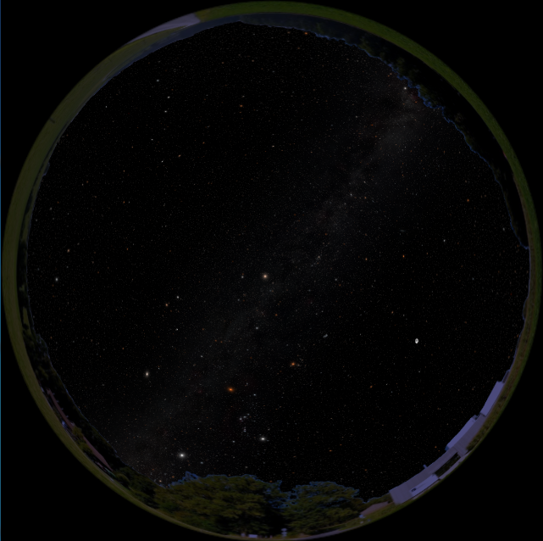
- View of the night sky with panorama
- Moonrise

2. Moon
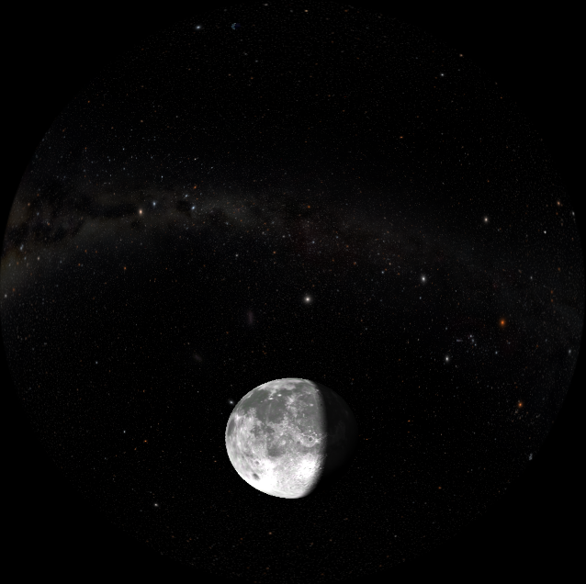
- Flight to moon
- Orbit
- Show tidal lock/ barycentric behavior
- Cut-out

3. Formation of a moon
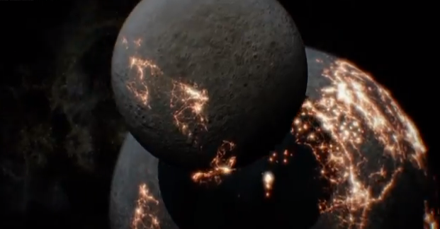
- Video clip

4. Mars
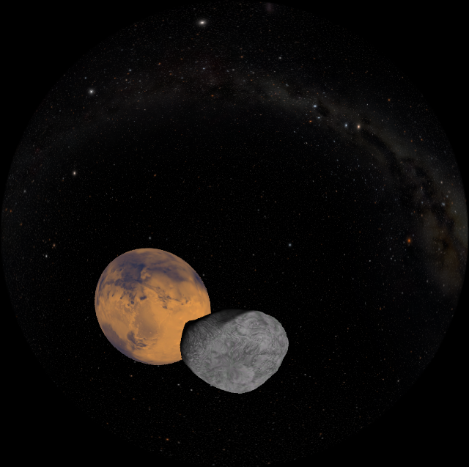
- Flight to Mars
- Switch to Phobos with view of Stickney crater

5. Jupiter
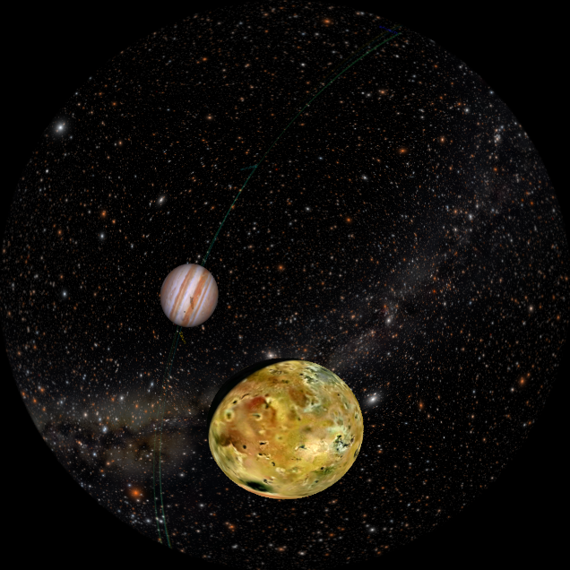
- Flight to Jupiter with orbits of all moons displayed
- Fade out all but the Galilean moons
  - Flight to Io
  - Orbit
  - Flight to Europa
  - Orbit
  - Cut-out
  - Flight to Ganymede
  - Picture “moon size comparison”

6. Saturn
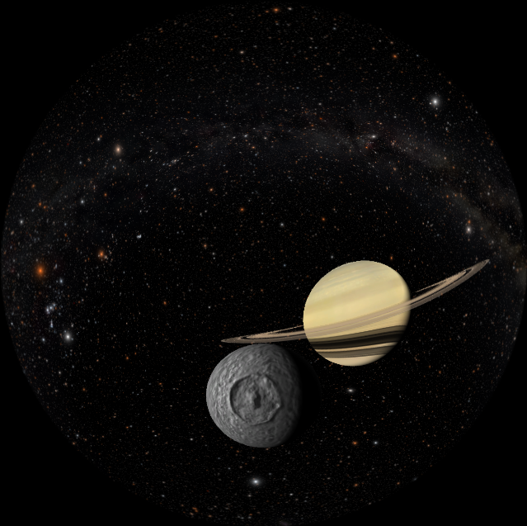
- Flight to Saturn
- Orbit
- Dive into Saturn’s rings
  - Flight to titan
  - Orbit
  - Flight to Mimas
  - Picture “Comparison to the Death Star”

7. Uranus
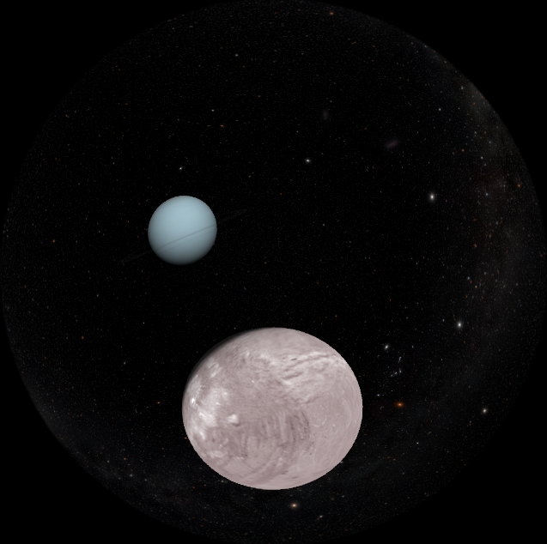
- Flight to Uranus
  - Flight to Miranda
  - Orbit

8. Neptune
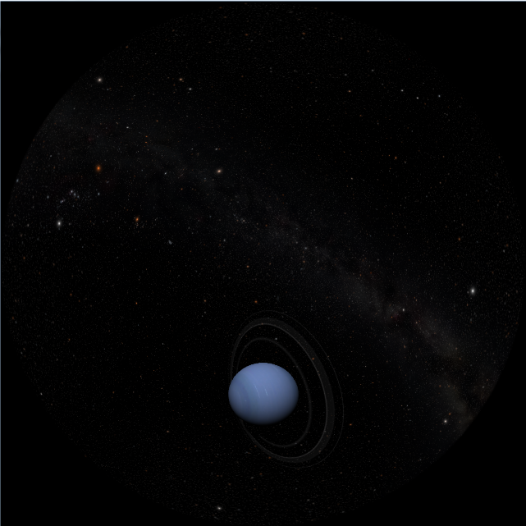
- Flight to Neptune
- Orbit
  - Flight to Triton
  - Show retrograde orbit

9. Pluto
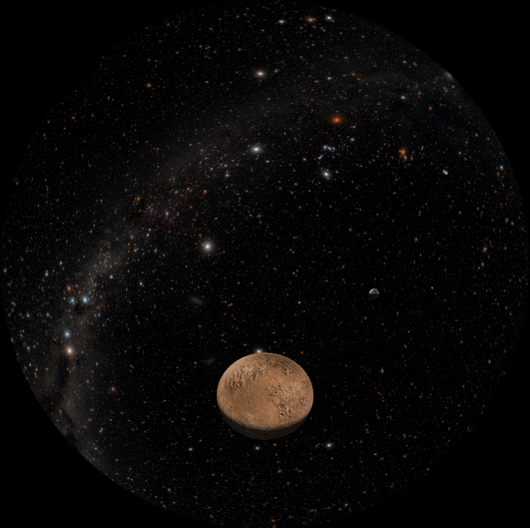
- Flight to Pluto & Charon
- Show orbit, and size

10. Ida & Dactyl
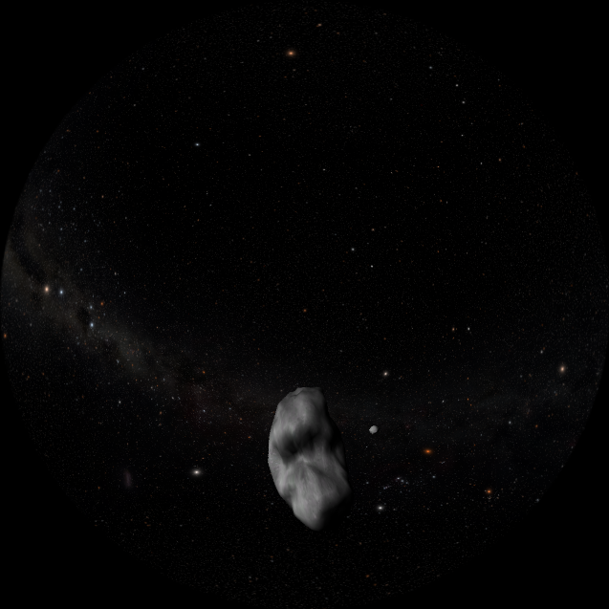
- Flight to Ida & Dactyl
- Show orbit

11. End
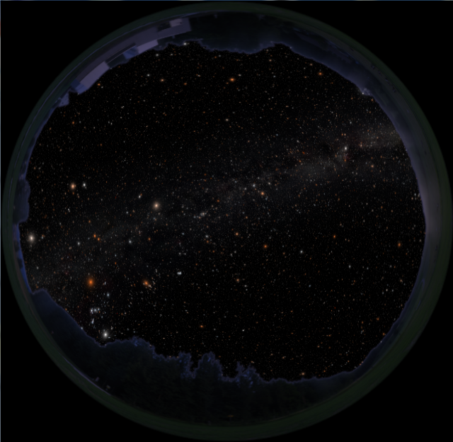
- Land on earth
- Finish

