Apfelsäure

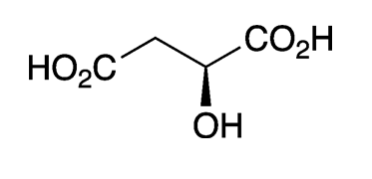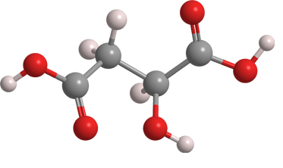

Malic acid, a hydroxydicarboxylic acid, is found in all forms of life. It exists naturally only as the L-enantiomer. It should not be confused with the similar sounding [maleic](https://www.acs.org/content/acs/en/molecule-of-the-week/archive/m/maleic-anhydride.html)  and [malonic](https://www.acs.org/content/acs/en/molecule-of-the-week/archive/m/malonic-acid.html) acids.

L-Malic acid gives many fruits, particularly apples, their characteristic flavor. It is often referred to as “apple acid”. The word malic is derived from the Latin mālum, for which *Malus*, the genus that contains all apple species, is also named.

The global market size for malic acid (natural and manufactured1) is ≈US$200 million; the US market is ≈$35 million. The primary end use in the United States is for flavoring beverages, foods, and confectionaries, with much smaller quantities used in cosmetics and personal care products. The price of malic acid ranges from US$0.90 to $10.00/kg, depending on the purity, quantity, and end use.